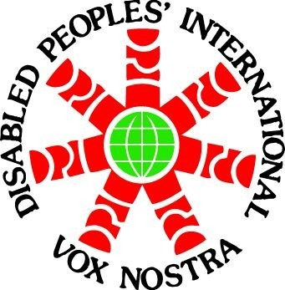

Press Release

Voices from the Global South resonate at the Civil Society Forum ahead of the 5th Conference of State Parties on CRPD

New York, September 11: A packed hall was a testimony to the fact thatvoicesfrom the Global South were loud and clear at a Side Event organised by Disabled People’s International (DPI) at the Civil Society Forum ahead of the 5th Conference of State Parties on the Convention on the Rights of Persons with Disabilities.

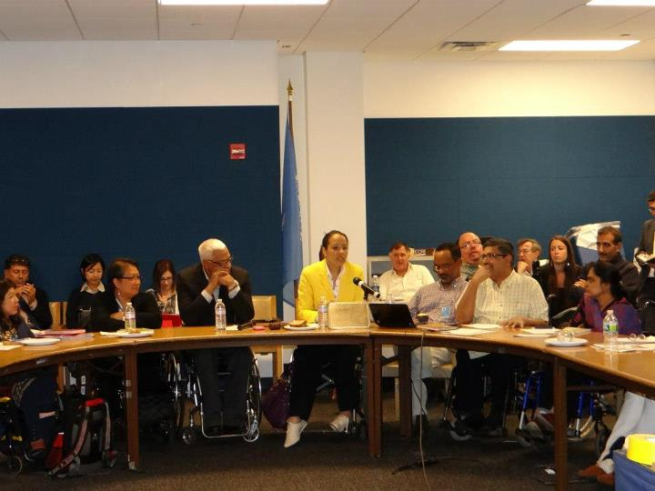

Judith Heumann, Special Advisor on International Disability Rights, US Department of State opened the Session. In her remarks, she underlined the importance of the proactive role that disabled people’s organisations (DPOs) need to play for the voices from the Global South to be truly heard. Shuaib Chalklen, UN Special Rapporteur on Disability chaired the Session, while Charlotte McClain-Nhlapo, Coordinator, Office for Disability and Inclusive Development, USAID co-chaired it. Chalklen spoke on the role of DPOs, networking and communicating while Charlotte highlighted the changing dynamics of development and how aid is just only one aspect of it.

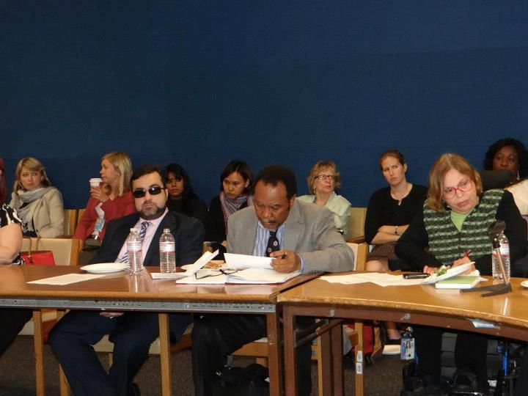

On the panel were Coomara Pyaneandee, disabled activist and nominee to the CRPD Committee, Mauritius; Danlami Basharu, disabled activist and nominee to the CRPD Committee, Nigeria; Leslie Emmanuel, Regional Development Officer, North America & Caribbean, DPI; Meenakshi B., National Disability Network, India; Mohammed Ali Loutfy, Senior Adviser, Lebanese Physical Handicapped Union; Moosa Salie, Chairperson, World Network of Users & Survivors of Psychiatry; Saowalak Thongkuay, Regional Development Officer, Asia-Pacific, DPI; and Venus Ilagan, Secretary General, Rehabilitation International.
What came out from the presentations and discussions was that there is a need for all stakeholders in the disability movement across the globe, especially those that are influencing policies, to listen and actively engage people with disabilities from the South. An emphasis was placed on the paradox this year where 9 of the nominees to the CRPD Committee are from the Global South, a region where not even 50 percent of the countries have ratified the Convention. The challenges in implementation of the Convention in the global South were put on the table. This included the lack of commitment that is seen from the Global South primarily due to three main reasons - little participation that the Global South has received towards the drafting of the Convention; lack of adequate financial resources and lack of political will. There is a need to include persons with disabilities in the political leadership. The lack of participation cannot be cited as reasons for non-implementation of the CRPD. The new world order should be that of regional participation and cooperation.

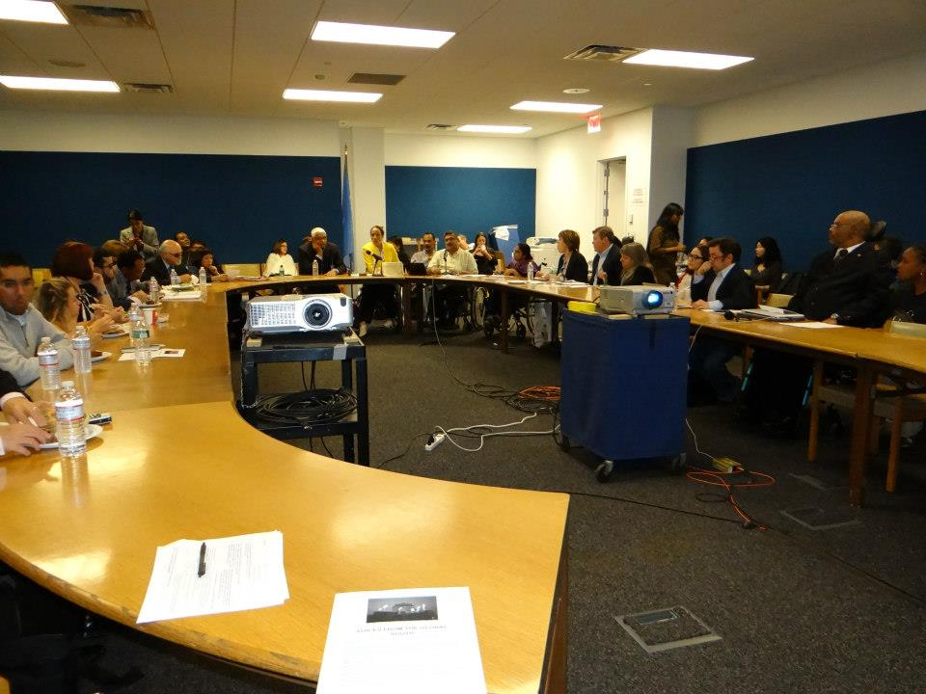

An emphasis on including people with disabilities from the Global South, especially women and girls with disabilities and those with psychosocial disabilities, in the social and economic framework was made. This holds special significance because of the post-2015 development framework and the discussions around aid effectiveness post Busan.

The need for sharing of information and networking was highlighted, wherein the close collaboration between DPI and World Network of Users and Survivors with Psychiatry was placed as an example.

The fact that there is a need to break the myth that the Global South does not have the ‘capacity’ to participate and engage in the process of development planning was highlighted.

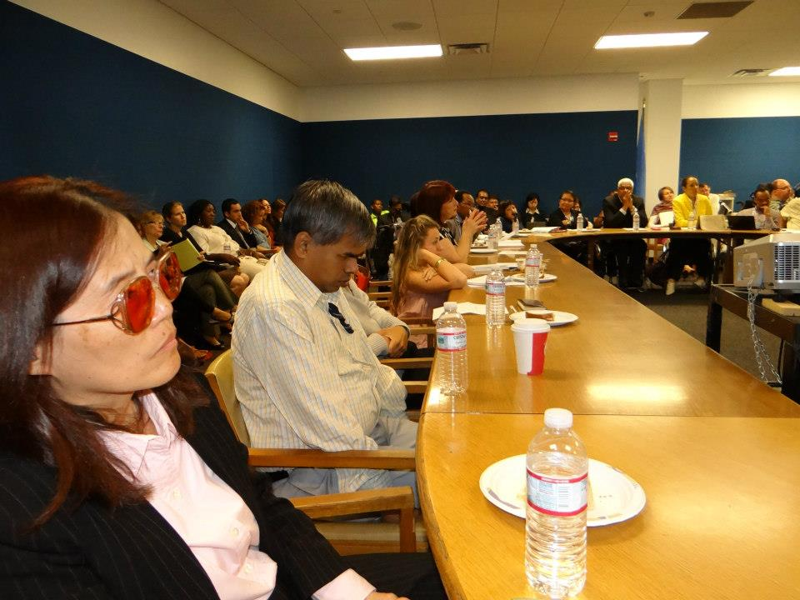

What came across most strongly wasthat people with disabilities need to be at the forefront of the movement. It is therefore an onus on the part of the INGOs and donors and international agencies, who are working on disability, to employ people with disabilities from the Global South in decision making roles. Unless that transition takes place, the paradigm shift will never take place. And, ‘Nothing About Us, Without Us’ will just remain that, a slogan!

A detailed report, based on the presentations will be prepared soon.

For more information, please contact:
Dorodi Sharma at osd.dpichairperson@gmail.com

