
EUROPEAN NETWORK
ON INDEPENDENT LIVING (ENIL)

Pilot Study: The UN Convention on the Rights of Persons with Disabilities

Debbie Jolly
2010

debbie.jolly@virgin.net


ENIL is supported by the European Commission and Generalitat Valencia

Contents

Why was a Pilot Study Necessary?................................................................................ 4

Executive Summary………………………………………………………………………….. 5

1. Responses and Strategy…………………………………………………………………... 7

3. Responses to web Questionnaire

- How would you describe your government’s knowledge of the convention?...... 8
- Has your Government ratified the Convention?...................................................... 8

- If your government has signed or ratified the convention have any changes been made since the convention legally came into force in May 2008?................................... 9

- If there have been changes how would you describe these?................................. 9

- Do you see any will from your government to make positive changes for disabled people in relation to article 19 on Independent Living?..................................................... 10

- Has your government begun to monitor the convention?...................................... 10

- If monitoring, has your government involved a disabled peoples’ organisation (DPO) in the monitoring process?...................................................................................... 11

- If a DPO is involved in Monitoring is it working from the medical/traditional perspective (without a focus on the social model and independent living)?......................... 11

- How much do you believe the convention will improve things for disabled people in your country in the next 12 months?........................................................................... 12

- Do you think the convention is a useful tool for the disabled peoples/Independent living movements work?................................................................................. 12

- Do you think you have enough information on the convention?........ 13
4. How could the convention be an even better tool for the movement-What do you think is needed to strengthen its impact? (Written responses)……………………………………. 14

5. Further Comments (written responses)……………………………………………….. 21

6. Conclusions …………………………………………………. ………………………………25

Resources………………………………………………………………………… 26

Annex 1
All written comments (unedited)………………………………………………………… 28

Why was a Pilot Study Necessary?

There are many tool-kits, factsheets and papers on the UN Convention for the Rights of People with Disabilities (CRPD), but little information that focuses on what disabled people think of the CRPD. For example: How much information do people have on what their governments are doing? Is the CRPD a useful tool for Independent Living and for the disabled peoples’ movement? What could strengthen it? What are the perceived problems in implementation? In fact while we could easily access the number of signings and ratifications to the CRPD through the Enable web site (see resources section), the only way we knew the problems in the implementation across Europe was through informal discussions, and even then many did not know what was happening in their own countries because governments and monitoring bodies were not publicising strategies or actions.

It was time for a small scale study to gage the mood of disabled people and non-disabled people regarding the CRPD and its effectiveness so far- ENIL set up a 4 minute web questionnaire. We wanted to find out what people knew about the CRPD, what information was available, what difference people thought the CRPD would make and what was happening or not happening in the different countries of Europe and elsewhere. This was not set up as any deep academic study (although one is long overdue), but as a first stage questioning and fact-finding exercise on the practicalities of the CRPD.

The web questionnaire produced a wide range of thoughts and comments with written comments numbering almost a hundred. However there was a great deal of agreement in the answers to many of the quantitative ‘click through’ questions showing that on an international scale the CRPD appears to be failing more often than it is succeeding in its initial stage.

Executive Summary

●117 responses were received from 31 countries. These included European countries as well as Africa, Albania, Ghana, Somalia, USA, Canada and Australia. Most responses came from the United Kingdom with the second highest number coming from Serbia.

●Just over sixty-nine percent of respondents identified as disabled and 30.6% identified as non-disabled

●Forty percent of respondents were employed by a Disabled Peoples’ Organization (DPO)

●Most respondents described their governments’ knowledge of the CRPD as poor. Over half 56.4% believed that their government’s knowledge of the CRPD was poor or very poor.

●Sixty-four percent of respondents said that their government had ratified the CRPD. Almost 15% didn’t know if their government had ratified or not.

●Fifty percent said that there had not been any changes for disabled people in their country since their government signed or ratified the CRPD. Twenty three percent didn’t know and almost 27% said there had been changes

●Changes were described as poor or very poor by almost 20% just 6.2% described the changes as good with almost 22% describing changes as ‘average’.

●Just 10% saw a positive will from their government to make changes in relation to article 19. Thirty-two percent believed there was ‘a little’ will, but a further 32% saw no will at all from their government to make any positive changes in relation to independent or community living.

●Twenty-four percent said that their government had began to monitor the convention. Yet the largest majority did not know if their government had begun to monitor or not.

●Almost half 45% did not know if the government had involved a DPO in the monitoring process. Only 21.3% claimed that a DPO was involved in the monitoring of the CRPD

●Just 22.2% of those who knew a DPO were involved in monitoring the CRPD said that they believed the DPO involved was an organisation working from the social model perspective with an understanding of independent living values.

●Almost half 45.2 % did not believe that the CRPD would improve things for disabled people in their country over the next 12 months. Almost 27% believed that there might be ‘some change’ and 18% believed that there would not be any changes at all in the next 12 months.

●Most respondents said that the CRPD was a good tool for the disabled peoples’ movement at 48.9% with 40% believing the CRPD was an excellent tool for the disabled peoples’ movement. Just over four percent felt it was either a poor or a very poor tool

●Over half 56% said that they had enough information on the CRPD. However, this was not supported by either the answers to the other ‘click through’ questions outlined above or the written comments. This is because there was a great lack of information on what was happening at country levels.

●There were almost 100 additional written comments. The majority focused on ways that the CRPD could be strengthened. The key areas in strengthening the CRPD were noted as promoting greater awareness, research and more information. Many respondents said that monitoring and evaluation processes must be strengthened with sanctions applied to those governments that did not implement or ratify.

●The legal basis of the CRPD and options for legal redress stimulated a great deal of comments, as did the involvement and structures of DPO’s (which came in for some criticism). Many believed that the DPO sector itself needed strengthening to deal with the extra tasks that the CRPD brought, some were sceptical about DPO’s ability to address issues or problems in the CRPD. Others felt that their country had an inadequate base or understanding of the social-relational model/social model and of independent living values.

●The value of the CRPD was recognised as a lever for national legislation. For example the convention played a significant role in the development of ideas for Serbia’s anti-discrimination Act and as a lever in Ireland for the Mental Capacity Bill. Some also thought that the CRPD gave a documentary equality to disabled people which was lacking previously.

●DPO’s came under fire for serving their own needs and those of ‘disability elites’ whilst ignoring the needs of disabled people as a whole or not taking into account individual voices. Yet it was also noted that funds for extra work, and knowledge within the DPO sector were also lacking.

●Suggested future strategies focused on more information, developing an international network to share experiences and knowledge and more consultations and research. Several suggested that a guide should be produced on the CRPD in national languages.

- Strategy and Background of Responses

The web questionnaire was set to run for two months. The aim was for 70-80 responses from a range of countries. The aim was surpassed with 117 responses from 31 countries. The chart shows responses where the country produced more than one input to give an idea of the balance of views. Most responses came from the United Kingdom with the second highest number coming from Serbia.

Countries with More than one Response
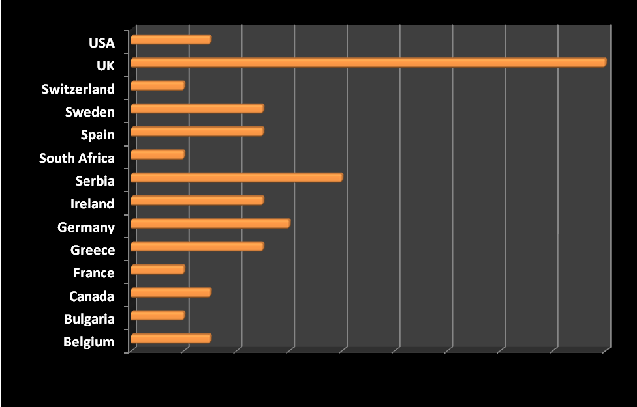
Other countries that responded were Albania, Australia, Cyprus, Ghana, Iceland, Luxemburg, The Isle of Man, Scotland, Somalia, Czech Republic, Denmark, Estonia, Italy, Latvia, Portugal, and Slovenia.

Individual Background of those Responding

Gender: 58% female and 42% male responses

Disability status: 69.4% identified as disabled and 30.6% were non-disabled

Employment: 63.9% employed, 22.9% unemployed, 13.3% self-employed

Employed by a DPO: 40%

Member of Disability organisation: local 45.9%, national 58.8%, European 24.7%

Not a member of any Disability organisation: 23.5%
- Responses to ‘click through’ questions on web questionnaire

- How would you describe your government’s knowledge of the convention?
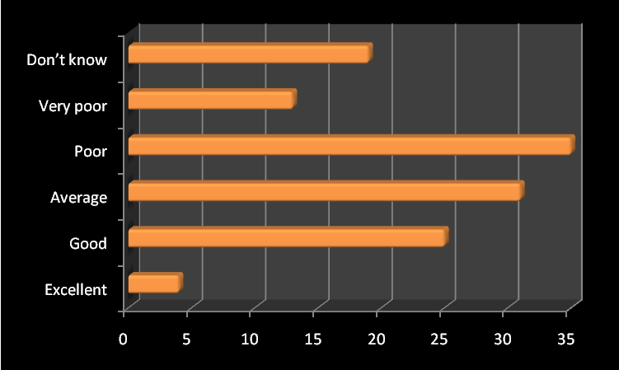
N=Excellent 4 (3.4%), good 25 (21.5%), Average 31 (26.5%), poor 35 (29.9%), very poor 13 (11.1%), don’t know 19 (7.7%)
Just 3.4% (4) of respondents thought that their government’s knowledge of the CRPD was excellent with 56.4% (48) believing that their government’s knowledge was poor or very poor. The section with the highest agreement at 29.9 % was that government knowledge on CRPD was poor

- Has your Government ratified the Convention?
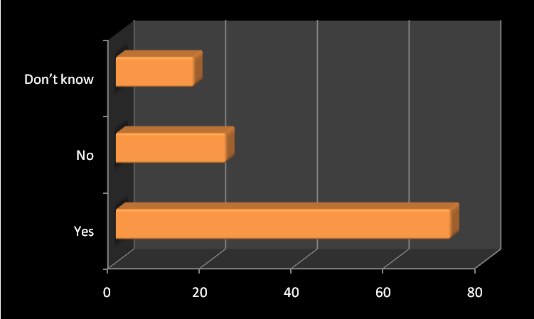
N=Yes 73, (64%) no 24 (21.1%) don’t know 17 (14.9%) no response 3

Sixty-three percent of respondents (73) claimed that their government had ratified the CRPD and 21.1% said that their governments hadn’t ratified the CRPD. Almost 15% (17) did not know if their government had ratified. However, it was clear when checking the answers that some who though that their government had ratified were from countries that had not ratified and vice-versa. Although this was a small minority, it shows that there is a further lack of knowledge in relation to ratification processes.

- If your government has signed or ratified the convention have any changes been made since the convention legally came into force in May 2008?
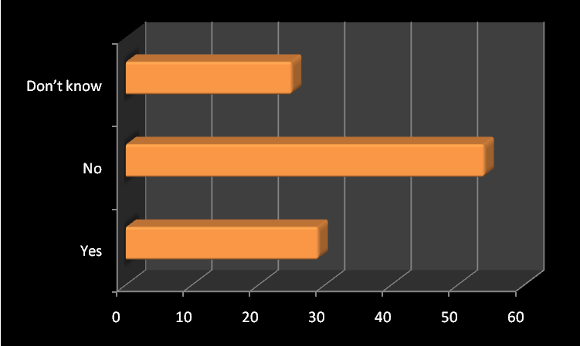
N=Yes 29 (26.9%), No 54, (50%) don’t know 25 (23.1%), no response 9
Seventy-three percent (79) said either that there had been no changes or they did not know if there had been any changes with almost 27% (29) claiming that changes had been made. However, it was not possible to trace in which countries the changes had been made due to the limitations of the web questionnaire program

- If there have been changes how would you describe these?
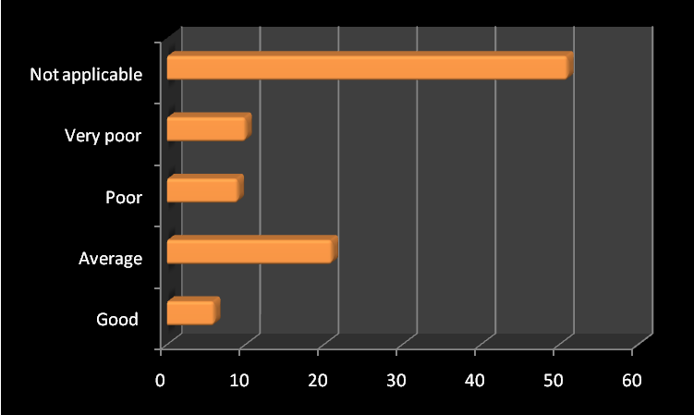
N=Excellent 0, good 6 (6.2%), average 21 (21.6%), poor 9 (9.3%), very poor 10 (10.3%), not applicable 51(52.6%), no response 20
Just 6.2% described the changes as good. The majority described the changes as average at 21.6%. However, in all 19.6% described changes as either poor or very poor. This gives an overall positive picture of changes by governments with 27.8% saying that they considered changes made were good or average, unfortunately few followed up what these ‘good changes’ were in the further comments section which would have been useful to get a clearer picture of one of the few areas that obtained a positive result.

- Do you see any will from your government to make positive changes for disabled people in relation to article 19 on Independent Living?
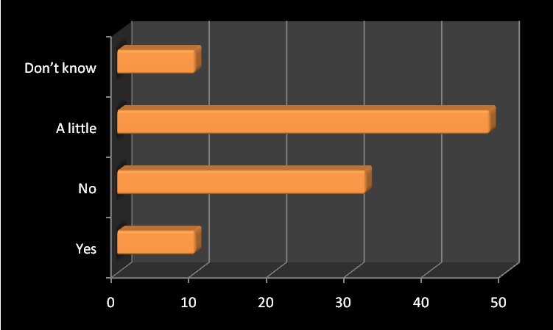
N=Yes 10 (10%), no 32 (32%), a little 48(48%), don’t know 10 (10%) no response 17
Answers to the perceived will of national governments to make positive changes for disabled people in relation to article 19 on independent living gave a clearer divide. Only 10% saw a positive will from their government on article 19 compared to 32% who gave a definite no to this question. The majority did see ‘a little’ government will, but was this based on wishful thinking for the future? The 10% that didn’t know may suggest that this is an issue that has had little, if any, discussion or awareness from national governments.

- Has your government begun to monitor the convention?
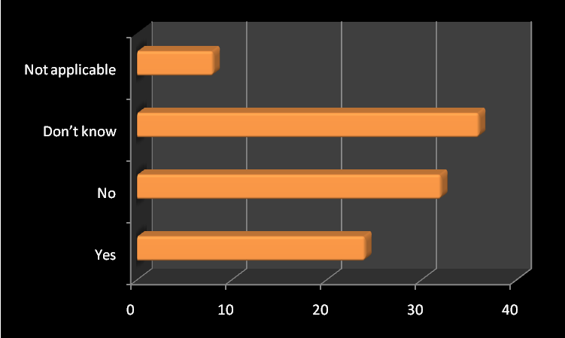
N=Yes 24(24%), no 32 (32%), don’t know 36 (36%), not applicable 8 (8%), no response 17
Twenty-four percent said that their government had begun to monitor the convention. This is a requirement for states parties that have ratified. The largest percentage did not know if the government had begun monitoring showing a lack of knowledge on government actions or possibly the status of ratification. Eight percent said that the question was not applicable because the government had not ratified.

- If monitoring, has your government involved a disabled peoples’ organisation (DPO) in the monitoring process?
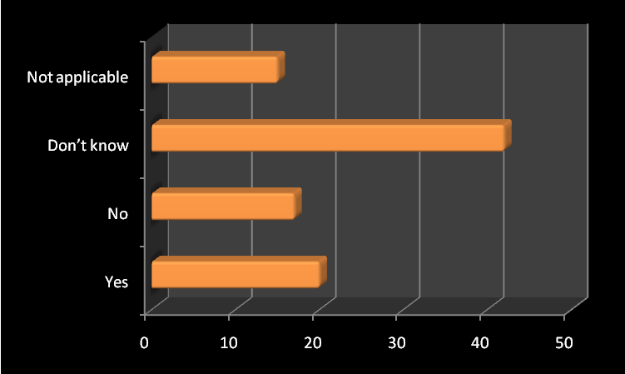
N=Yes 20 (21.3%), no 17 (18.1%), don’t know 42 (44.7%), Not. Applicable 15 (16%) no response 23
Once again the majority did not know if the government had involved a disabled peoples’ organization in the monitoring process at 44.7% this response was higher than all others. Just 21.3% said that a DPO was involved in the monitoring process. It is a requirement of article 33 of the convention that disabled people and DPOs are included and involved in the monitoring process. Yet this is not always followed or a nation may choose a disabled person working within a particular sector of government and claim that this is involving disabled people.

- If a DPO is involved in monitoring is it working from the medical/traditional perspective (without a focus on the social model and independent living)?
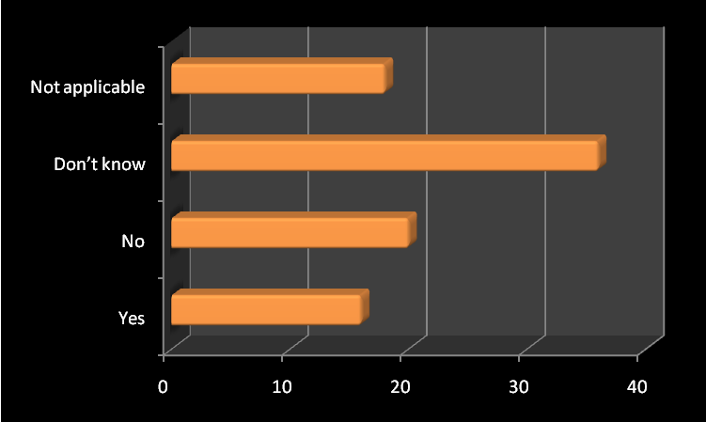
N=Yes 16 (17.8%), no 20 (22.2%), don’t know 36 (40%), not applicable 18 (20%), no response 27
Unsurprisingly the majority did not know, however the second highest percentage said that the DPO involved in monitoring was not working from a medical/traditional perspective (without a focus on the social model and independent living) . Yet 17.8% said that there was a medical/traditional DPO involved in monitoring. Many of the written comments given in question 11 and in the ‘further comments’ section raise the issue of DPOs and the problems arising in different types of DPO in relation to the convention.

- How much do you believe the convention will improve things for disabled people in your country in the next 12 months?
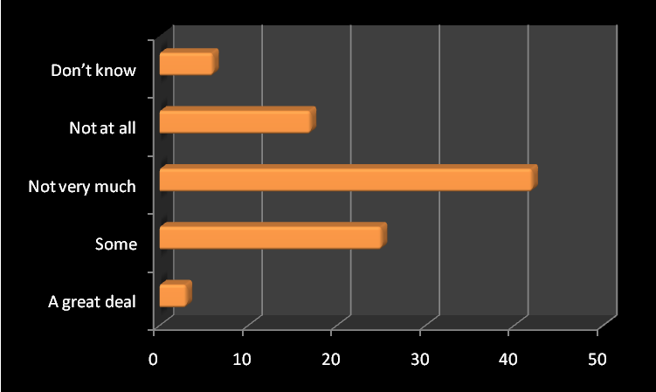
N=A great deal 3 (3.2%), some 25 (26.9%), not very much 42 (45.2%), not at all 17 (18.2%), don’t know 6 (6.5%) no response 24
Just over 3% believed that the CRPD would improve things for disabled people in their country within the next 12 months. The majority 45.2% did not believe that things would change greatly, agreeing with the statement that ‘not very much’ would change in the next 12 months. Just over 18% did not believe that there would be any changes at all, but almost 27% thought there would be some change. The percentages may be related to the rate of ratification, yet in question 2 sixty-four percent had claimed that their country had ratified the CRPD

- Do you think the convention is a useful tool for the disabled peoples/Independent living movements work?
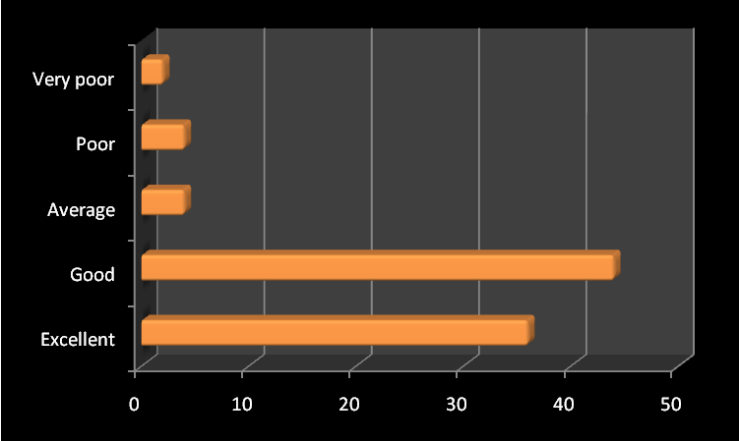
N=Excellent 36 (40%), good 44 (48.9%), average 4(4.4%), poor 4(4.4%), very poor 2 (2.2%) no response 27

Most people thought that the CRPD was a useful tool for the disabled peoples’/independent living movements work. The majority and almost half of all responding to this question felt it was a good tool, with 40% believing that it was an excellent tool. Just over 4% felt it poor with 2% describing it as very poor. With almost 89% agreeing that the CRPD is an excellent or good tool for the movement, there is strong support for the potential of the CRPD; however, it is the implementation measures that will decide how well it will work. The answer to the previous question on changes expected in the next 12 months also suggests that we may have a long way to go before we see positive effects of the CRPD.

- Do you think you have enough information on the convention?
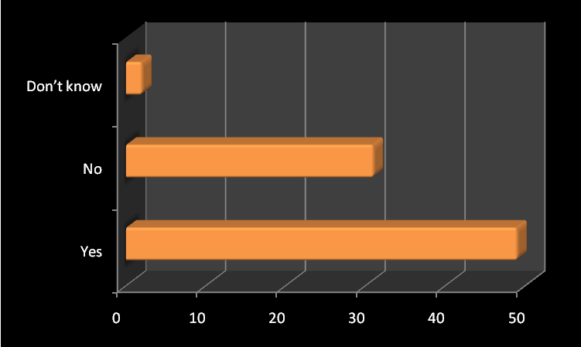
N=Yes 49 (55.7%), no 37(42%), don’t know 2 (2.3%) no response 29
Over half of respondents 55.7% said they thought they had enough information on the convention, with 42% disagreeing and believing that they did not have enough information. This theme is extended through the ‘open comments’ and further comments that were given providing a contradiction as those filling in the written comments appeared to want more information. In addition, the answers to some of the questions here and the large number of those in the ‘don’t know’ category suggests that while there may be enough information on what the convention is and the number of signings and ratifications , large areas of information are not available in connection with government actions and monitoring processes in particular countries.

The next sections look at the ‘open responses’ or the written comments that were given. These sections develop many of themes raised here in a more significant way. There were two options for people to write more detailed thoughts. These were in question 11 which asked: How could the Convention be an even better tool for the movement- what do you think is needed to strengthen its impact? And secondly in the Further comments section. Responses to both options gave almost a hundred separate comments producing 97 extra comments. These comments give more information on the way people feel about the convention in their own countries than the ‘closed questions’ which relies on respondents choosing one option from several fixed statements. .

- How could the Convention be an even Better Tool for the Movement-What do you Think is Needed to strengthen its Impact?

This section produced 63 comments. Main areas were around a stronger implementation of the CRPD, more sanctions for governments that do not implement properly and clear views that more lobbying, information and actions are also needed from disabled peoples’ organizations. Below is an outline of the key areas raised under specific headings. But one overall comment sums up the entire process:

It can be strengthened by the basic recognition of the right to self-determination

In addition, one of the most problematic areas for disability rights is the notion of ‘reasonable accommodation’ This is a term that appears only in disability legislations at nation and international levels- basically it tells us that disabled people should have the same rights as everyone else as long as it is not too expensive, or too troublesome-we can have rights as long as it is considered reasonable by others. This does not appear in other equality legislation as far as I am aware. So the comment below is very pertinent

Remove the notion of reasonable accommodation and relegate it to the enlightenment bin!

More Research and Awareness Raising
Many people said that more research and awareness was needed amongst national politicians and governments, the public and within the disabled peoples’ movement itself.

At this stage, conducting more research on CRPD and national disability sector. Educate the public about CRPD involving the disability community in the process, conducting grass-roots consultations, setting up mechanisms for monitoring and evaluations, designing strategies for effective implementation of CRPD

There is a need to unpack it to various stakeholders so that they understand what it really means and its implication. Not many people are aware of it, including countries that have ratified it. Unless there is deliberate awareness, implementation, monitoring and evaluation not much will be gained from it.

Awareness raising rights on the convention and how it must be addressed by the agencies of the state, most agencies have not heard about the convention and the European Human Rights Act

Further awareness raising on the convention amongst persons with disabilities themselves and the general public as well. Working with governments on its effective implementation and monitoring

In the Czech Republic people with disabilities, their families and public to be informed much more about existence of the convention to understand it right and to speak for themselves much louder than now

Greater community education informing people of the convention and their rights/authorities of their responsibilities

Greater promotion and education

Implementation, Monitoring and Sanctions
However, the largest number of comments focused on the areas of effective implementation and monitoring, and the possibility of imposing sanctions or penalties on those governments that did not take the CRPD seriously. This includes those countries that have not yet ratified the convention. (See resources for Enable link and a list of ratifications of the Convention and the optional protocol).

International pressure on all countries (like mine: Switzerland) that did not yet ratify

Many comments suggested that tougher sanctions were needed including time sanctions and penalties for nations that fail to implement properly:

In my opinion it is needed that the governments which do not realize and violate the convention will get hard and painful sanctions [from] the UN

A strong external control on the implementation with a possibility for penalties

Enforcement powers against governments

For our government to be forced to act

Have UN mechanisms to sanction governments in failing to comply with the convention

Strict United Nations monitoring and open reporting. Plus with even more states ratifying the convention it becomes a stronger piece of international law.

The government has to be forced to apply properly the articles of the convention. Monitoring process must be initiated.

The impact of the convention is limited due to lack of government action. Enforcement mechanisms should be stimulated to encourage implementation

A strong external control on the implementation, with a possibility for penalties

Good and valid and above all recurrent surveys or census to evaluate or monitorize the progress of the disabled persons in all the aspects of their participation in the society.

There must be sanctions and time schedules to urge the governments using the convention in the daily life

Many people also said that more pressure should be put on national politicians and national governments to make the convention more effective.

Legal Basis and Understanding the Different Country Issues
There were firm ideas that the articles of the convention should be adopted as national law, and that the CRPD should be regulated and tested through the national legal systems

We need written laws to imply [implement] it

Implementacija Konvencije u Nacionalno zakondavstvo or
Implementation of the Croatian Convention into national legislation

We must go to all courts and force to force all governments to apply the convention

Have legal advisors like Citizens Advice bureau who will actually take cases to law and make these a precedent beyond the individual. Not that I expect any of this to happen

note Citizens Advice Bureaus are agencies based in the UK advising on rights and legal issues, although not primarily focused on disability- a better route might be the Disability Law Centre based in London which deals exclusively with disability issues

Legal advice and funding for lawsuits against state and local governments blocking the implementation of the convention

But there were also issues of national legal frameworks within each country for example Scotland which has a devolved government. The comment begins with a reference to two of the reservations made by the UK government to the convention on the denial of inclusive education and not allowing disabled people into the armed services. It is clear to many that the option to make reservations against any part of the CRPD undermines its intent.

If the UK government had not adopted opt outs on special education and the armed services.. Please note however, that our answers are difficult to frame because we also have a devolved government in Scotland and some of our answers concern its response to the convention e.g. monitoring

Others stated that it was important that national and regional differences were respected

The convention is an important legal instrument, but it is just that. Any strategy aimed at motivating changes in behaviour and attitude needs to combine the legal instruments with other instruments (economic and social) that facilitate the transition. Another important aspect of these strategies is that they must respect the characteristics and customs, as well as the needs, regionally and locally. Unfortunately, the convention makes no reference to these aspects.

Make it clearer how it interacts with each nation’s legislation. The convention is irrelevant when governments focus on primary legislation. So the convention has to act as a lever to improve nation’s own legislation

This is very important, but also has the potential for undermining the convention. For example Hungry have declared that article 12 around the exercise of legal capacity for all disabled people is unconstitutional according to its national constitution. It is not possible for any country to put a reservation against article 12. This article in particular has caused a great deal of discussion with many states parties objecting to it (see ‘Legal Opinion Letter on Article 12 of the CRPD’ in the resources section).

DPOs and Disabled People
Article 33 of the convention says that disabled people and their representative organisations must be actively involved in the monitoring process. This sets a good precedent, however some pan disability organisations still focus on the medical aspects of impairment, rather than the effects of disablement which is in the spirit of the Convention. A good disability organisation should have independent living and the social model woven into its operating strategies and ethos. It should have a majority of disabled people at the decision making level and show a preference for employing disabled staff, whilst being pan disability rather than focusing on one particular impairment group. The best organisations are run and controlled by disabled people.

Coordinated effort between partners strategy for implementation and monitoring civil society involvement- disabled community taking the lead

Get government to understand its importance in assuring disabled peoples rights and importance of using DPOs from the beginning

A practical guide for how to advocate for the convention for DPOs and on how to domesticate the convention

Disabled people and their organisations need to be strengthened to be able to monitor implementation of the convention and advocate for it, through awareness raising, training, campaigns ect. Also it is useful to enable them to collect relevant data and produce shadow reports on the implementation of the convention together with regional Governments reports to the UN

Need to get disabled peopled involved

We need more disabled people to be involved in all kinds of movements

Strengthening of DPOs to monitor governments’ implementation of CRPD

Strengthen the participation mechanism for inclusion of representative DPOs in decision making process and setting up monitoring mechanisms

To teach PWDs about the convention consistently to make monitors for every field. We need to be outside

The convention is fundamental for the movement but we need Spain to do more to get it enforced. To strengthen the impact we have to BE there and make ourselves visible; remind politicians what they have said and promised (original emphasis)

One respondent was not happy with what they saw as a ‘victim approach’ to the design of the questionnaire

DPOs need to train themselves in the use of the tool. Don’t blame everything on the government. We are not helpless victims as this questionnaire suggests

However, the answers suggest that it is governments that are posing some of the main problems in the implementation, validating the design. At the same time DPOs should, of course, train themselves in the use of the ‘tool’ and many are doing that.

Finally an important point

To be more respected by the political institutions in your own country, and don’t fight against each other inside your organisations

Social Model vs Medical Model Cultures
As noted the CRPD’s underlying ethos is based on the social model /social relational model of disability as outlined in article 2.

Better knowledge among government and other officials as well as among DPOs and others of the convention and the social relational approach to disability it [the convention] is based on.

Implement and monitor it within the social model of disability. Make it a legal requirement that disabled people are informed of it and how it can be used to give them parity in living autonomously and independently.

In Italy we need to start the ICF method and more finance explaining about the independent living fund. Because of the Federalist change inside 20 regions, we are a lot of different positions

Note: ICF refers to International Classification of Functioning developed by the World Health organisation

Funding/Economic Climate and its Impact
Few respondents concentrated on where the funding was going to come from to activate the awareness raising and the extra work that is needed from disability organisations. .

Disability awareness training to public workers and government officials- more funding available for developing monitoring capacities-more funding available for public awareness campaigns

One stark interpretation came from England, identifying the clear problems and extra work that disability organisations are focused on with overall cuts in public spending and the real threats to independent living at a time of economic crisis in Europe.

I do not think it [the convention] is going to have an impact at all on the ground particularly within an economic depression. Severe cuts are going to [be] made to Independent Living Funds, health and social care services, National Health Service and so on. The economic funding dictates the funding rights or no rights.

Problems with Frameworks already in Place
Responses regarding frameworks set up to deal with complaints regarding the rights of disabled people were also mentioned by another English respondent:

If disabled people and DPOs are given all the resources to equality of arms to due process within the courts to make complaints to the High Court, Equality and Human Rights Commission and of course the UN disability convention, which is not happening at all here in the UK. Disabled people and DPOs cant even have access to complaints procedures against public bodies and other service providers under the Disability Discrimination Act, Disability Equality Duty and Human Rights Act and if we do complain then we are harassed, bullied and victimised for complaining and speaking out and the Equality and Human Rights Commission do nothing when you make complaints to them-so what does this say?

In addition, issues of consultation without action were also raised in countries where governments were claiming to be activity consulting with DPOs

Our government has asked for events in 2010 to explore the process with disabled peoples’ groups they are presently in a consultation phase. The government has changed and is making cutbacks to services. In order to protect services for disabled people there could be government pledges and commitments to services that are reported to the UN convention and these could be checked to ensure that they are being kept. Also government can waste a lot of time consulting disabled people without doing anything

European Directive and European Focus
Few comments focused specifically on Europe as an area or on the powers of the European Council, commission or parliament. However two comments ensured that we have something to think about at the European level. For example one comment building on strengthening the legal basis suggested a European Directive, although it was not entirely clear what this would focus on, either the whole of the convention or a particular article e.g. article 19 dealing with independent and community living.

A European Commission Directive should be issued, not optional but compelling to all EU member states

However, it is highly unlikely that any directives will be issued either on specific articles or on the convention itself. A better focus would be to concentrate on strengthening the convention at national levels and supporting this as far as possible.

One comment drew on the back tracking on ratification by the European Parliament

More lobbying, better enforcement. European ratification now-not when all have ratified, more awareness raising

On November 26th 2009 the European Commission announced that they would ratify the CRPD. However, this decision was retracted in 2010 and the Convention will now be ratified at the formal European level only when all European countries have ratified. This is a strange and regressive step by the Commission and one that has not been publicised enough. It is clear that the wait for all countries to ratify could take a number of years. The ratification by the Commission is important for another reason and that is that their move will deny access to the legal structures of European Council in strengthening the impact of the CRPD as individuals and groups may be denied representation on the issue of the CRPD at the European Court of Human Rights. Thus speedy ratification by at the formal European level would clearly help the implementation and effectiveness of the CRPD across Europe and further afield.

- Further comments

There were 34 further comments. In the main these continued the themes raised in question 11 on strengthening the CRPD. There were some more positive statements, but also additional pointers on potential problems.

Recognising the Value of the CRPD
The CRPD was recognised as a marker of equality, and a benchmark through which to initiate domestic /country based legislation. For example in Serbia the convention was recognised as a lever in developing Serbia’s anti-discrimination law. However, it was also clear that ratification and implementation must involve partnership between the government and the disability movement

Convention played a significant role in development of ideas for Serbia anti discrimination law and national disability strategy. It is important that Serbia’s government and disability movement work in partnership towards its ratification and work together on implementing it more effectively

Two respondents felt that the documentary equality the convention offered would make a difference to disabled people.

I am glad that it exists and that my government eventually ratified it, though with opt outs, because it gives a documentary equality to us, which we’ve never had that can be used legally and throughout the world, as its from the UN even though not ratified worldwide> It sits our equality as rational and discrimination against us as irrational.

Konvencija će značajno doprineti poboljšanju položaja osoba sa invaliditetom or:
The convention will contribute significantly to improving the position of people with disabilities

One respondent from Ireland pointed out that the CRPD should also be recognised as something that acts as a benchmark for domestic legislation

Minister for Disability has stated publicly UNCRPWD will be ratified in the next session of Parliament-after summer recess-however mental capacity bill must first be passed. Primary or domestic legislation is the means of achieving IL [independent living] UNCRPWD best used as a benchmark for domestic legislation?

Further issues were raised around DPOs

Disabled Peoples’ Organizations
It is not clear how much knowledge there is of the CRPD within DPOs themselves, the comment below poses an interesting and worrying scenario

I work for an NGO our staff know the state/federal disability laws but have no idea of international law instruments such as the CRPWD are, if not unheard of, certainly unfamiliar and considered irrelevant. But they are highly relevant and should be used to illuminate poor practice/oppressive social structures in order to support a call for change. I think the convention has enormous instrumentality but lots of disability industry staff are not aware of it.

More problems were raised in relation to the structure of some DPOs and the ways some might ensure that the interests of their DPO or particular ‘disability elites’ are served rather than the interests of disabled people as a whole.

- Involving DPOs is not the only way to truly involve disabled people; individual disabled people should also have the opportunity to be part without having to join or organise with one or other groups
- DPOs sometimes further their own interests and that of a handful of active disabled people.

A further issue was raised in the ethos of certain DPOs and the inherent perceived corruptibility where money and power is involved.

It is hard (if possible…) to have Greek corrupted disability organization to work toward IL [Independent Living]

The lack of outreach and representativeness of some DPOs was clearly felt by another respondent

It [convention] is just another smokescreen and a token gesture and the convention will change nothing for us. This is the reality, especially for poor disabled people with no money and no voice

Lack of Political will and the Public Face of Governments
Many believed that there was little political will, not only in terms of the effective implementation of the CRPD, but in the sense of independent living, ratification and positive actions

In Spain one thing is what it should be and another is the face they show to Europe. There are a lot of words and not enough action. The central government passes the responsibility to the community governments and washes their hands on matters such as for example education. The communities are not obliged to comply with certain minimums which the EU Convention would oblige them to fulfil.

Others pointed out the lack of promotion and ‘glamour’ in the CRPD

It is not a topic in the public eye when compared to many other international conventions. One must be realistic in terms of priorities. There are unlikely to be any votes in it!

A lack of cash and lack of will by some governments was put forward as a deciding factor on the CRPD’s successful implementation

The CRPD is a powerful tool, but based on the lack of information given by my national government to regional and local governments and to the citizenship in general, I am very sceptical about its will to fully implement it and apply it

The national government until now cannot spend a necessary money about [on] people with a disability

Some countries are still waiting for the ratification process and many are still waiting for a framework of basic independent living

In the African country disabled people has no right for the independent living

My country ie Ghana has signed the convention but has yet to ratify it

As noted the European Commission has not yet ratified the convention, one respondent thought that this action would make a difference to other countries and their enthusiasm in ratifying

Strong pressure on European commission to ratify the convention at European level which would compel member states to fully ratify and implement the convention without reservations

Problems Identified in Monitoring and Representativeness
Although raised on a specific country issue the comment from Canada was interesting in providing an example of the contradictions that are happening at a time when the CRPD should be being implemented much more forcefully with monitoring tools forming a crucial part of measuring the process

I’m really glad Canada ratified the convention in March 2010 but in the same month, they decided to cut the one and only big survey about disabled persons in Canada, the PALS… we now have no survey remaining to monitorize the progress of disabled persons in Canada….not a good move

One respondent suggested that the CRPD networks are not as open as they should be leading to the assertion that it may be future generations that benefit from the CRPD

As an individual with significant disabilities I thought the UN CRPD would provide new opportunities I even [attended] event at the UN, but when it came to jobs and involvement people who are in the network are chosen. When I asked specific questions I got the typical run around. To me the UNCRPD provides hope but as long as disabled people cannot take ownership nothing much will change. Perhaps it will take future generations to take effect.

People also took the further comments section as an opportunity to suggest future strategies

Future Strategies Involving more Information and Awareness

It would be useful to have a basic, understandable guide about the convention from the UN

Please inform us about the convention, in our language that must be more useful, in that way we can diffuse this information to everybody

It would be useful if DPOs from different countries will regularly exchange experience and information on their activities related to the implementation of convention in their country, to help each other and learn from each other

Information on what different governments are doing is not always clear there should be a better organisation of this information and it should be widely available

More consultation and research are still needed at this stage mainstreaming the convention into government agenda, strengthening international cooperation in the implementation and monitoring of convention

More work needed in employment, mental health, guardianship, education to remove old institutional models

While the quantitative responses show that 55.7% believed that they had enough information, the written comments provide a slightly different story.

Another clear issue was that the web questionnaire could have been developed in a number of languages. This was clearly pointed out by one German respondent:

Es ware mehr wie sinnvoll diese Umfrage auch Deutsch oder anderen Sprachen zu erstellendenn sie knnen nicht erwarten das alle Menschen der englischen Sprache machtig sind!!!!!!!!!!!!!!!!!

It would be useful to create the survey in German or other languages because they cannot expect that all people of the English language are powerful!!!!!!!!!!!!!!!!!

Very true

- Conclusions
The majority of respondents believed that the CRPD offers a ‘good’ or ‘excellent’ tool for the disabled peoples and independent living movement.

However, human rights instruments are only as useful as their implementation strategies- it is clear that implementation needs significant strengthening if the CRPD is going to deliver human rights for disabled people.

At the time of writing there are 146 signatories to the convention and 89 ratifications. Some of the ratifications also include reservations against particular articles in the CRPD meaning that some states parties effectively reject some of the articles which are dedicated to disabled peoples’ human rights.

We have seen limited examples of areas in which the convention has contributed to ideas for national anti-discrimination legislation, and contributed to speeding up processes of national legislation on issues of mental health. Some believe that this will be one of the main functions of the CRPD. That is to bring national legislation to a standard that is more acceptable in relation to disabled peoples’ equality and rights.

The national implementation and monitoring strategies of those countries that have ratified can remain a mystery for some due to a lack of publicity, information and knowledge around the monitoring process. This combined with a perceived lack of government will and government inaction prompted a number of comments suggesting that the UN develop sanctions and penalties for governments that did not take the convention seriously.

At the same time a minority believed that the CRPD had prompted some changes from governments, although most described these changes as ‘average’.

Many believed that the DPO sector needed strengthening to deal with the CRPD, yet it was also apparent that resources for achieving this were likely to be limited. In addition with some countries far from any independent living strategy and others losing funds for the independent living strategies that are already in place, the future for DPOs appears challenging. It is challenging not only in terms of the work that needs to be done with the CRPD, but also in combating the idea that some DPOs are merely serving their own interests.

There is a clear need for structured research that uses stratified sampling techniques to develop themes raised here and elsewhere on the mainly negative views of the CRPD’s effectiveness.

On another level awareness raising, greater communication and networking between disabled people and national governments appears to be something that is crucial to the effectiveness of the CRPD. In addition, there were calls for more information, guides and networking events to share and develop knowledge and information amongst disabled people and others.

Resources

Disability Rights Fund resources page
http://www.disabilityrightsfund.org/resources-crpdtools.html
Accessed 03.08.10

Disabled Peoples International Treaty Intervener Timeline Tool
Available at
http://v1.dpi.org/lang-en/resources/details.php?page=952
Accessed 03.08.10

Disabled Peoples International ratification and Implementation toolkits
Available at
www.icrpd.net
Accessed 03.08.10

Disability Rights Promotion International (2007) Progress in Global Disability Rights Monitoring
Available at
http://www.yorku.ca/drpi/mediaMonitoring.html
Accessed 03.08.10

ENABLE
http://www.un.org/disabilities/
Updates on ratifications, signatories and on conferences of CRPD committee
Accessed 03.08.10

International Disability Alliance
http://www.internationaldisabilityalliance.org/
IDA promotes the effective and full implementation of the UN Convention on the Rights of Persons with Disabilities worldwide, as well as compliance with the CRPD within the UN system, through the active and coordinated involvement of representative organizations of persons with disabilities at national, regional and international levels
Accessed 03.08.10

Jolly, D. (2010) UN Convention Fact Sheets
33 Fact sheets on the UN Convention Including: Monitoring, Writing Shadow Reports, Monitoring, Legal Frameworks and breakdown of key articles in the CRPD
http://www.enil.eu/enil/index.php?option=com_mamblog&Itemid=113&task=show&action=view&id=450&Itemid=113
Accessed 03.08.10

Jolly, D. (2009) The UN Convention on the Rights of Persons with Disabilities
Contact debbie.jolly@virgin.net

Jolly, D. (2009) Personal Assistance and Article 19
http://www.enil.eu/elib/a... and independent living art 19 final2.doc
Accessed 03.08.10

Jolly, D. (2008) Research Paper on Community Living and Independent Living: Costs and Benefits
http://www.enil.eu/elib/a...nd the support of IL cost and benefits.doc
Accessed 03.08.10

Legal Opinion Letter on Article 12 of the CRPD
To facilitate State understanding of their obligations under the CRPD generally and article 12
www.internationaldisabilityalliance.org/wp-content/uploads/2009/08/LegalOpinion
Accessed 04.08.10

Office of the UN High Commission for Human Rights (OHCHR) initial reports on national progress of CRPD 2010
Available at
http://www2.ohchr.org/english/issues/disability/submissions.htm
Accessed 03.08.10

Producing NGO Shadow Reports to CEDAW: A Procedural Guide to producing shadow reports for human rights treaties
Available at http://www1.umn.edu/humanrts/iwraw/
Accessed 03.08.10

Annex 1
All written comments (unedited)

11. | How could the Convention be an even better tool for the movement-What do you think is needed to strengthen its impact?

Open responses (1-63)

Response

- disability awareness training to public wokrers and gov officials- more funding available for developing monitoring capacities- mopre funsing available for public awareness campaigns
?
A European Commissions directive should be issued, not optional but compelling to all EU member states.
A practical guide for how to advocate for the convention for the DPOs and on how to domesticate the convention
A strong extern control on the implementation, with a possibilty for penalties
An international obligation for countries/governments to implement recommendations, similar in a way to Human Rights legislation.
Articles need to be more specific - eg. Article 19 - take out the wriggle room. ie no mention of how assistance is to be organised, right to choose a provider or to self employ etc
As our government is very new we have yet to find out its intentions.
at this stage, conducting more research on CRPD and national disability sector.educate the public about CRPD.involving disabled community inthe process.conducting grass-roots consultations.setting up mechanisms for monitoring and evaluationdesigning strategies for effective implementation of CRPD
awareness raising rights on the Convention and how it must be addressed by the agencies of the state. most agencies have not heard about the convention and the European Human Rights Act
Better knowledge among government and other officials, as well as among DPO and others, of the convention and the social/relational approach to disability it is based on.
coordinated effort between partners.strategy for implementation and monitoring.civil society involvement.disabled community taking the lead.
Disabled people and their organizations need to be strenghten to be able to monitor implementation of the convention and advocate for it, through the awareness raising, training, campaigne, etc.Also it is useful to enable them to collect relevant data and produce shadow report on the implementation of the convention together with regual Governments report to UN
DPOs need to train themselves in the use of the tool. Dont blame everythikng on the government. We are not helpless victims as this questionnaire implies.
enforcement powers against governments
For our government to be forced to act.
Further awareness-raising on the Convention amongst persons with disabilities themselves and the general public as well. Working with governments on its effective implementation and monitoring
Get government to understand its importance in assuring disabled peoples rights + importance of using DPOs from the beginning
good and valid and above all recurrent surveys or census to evaluate or monitorize the progress of the disabled persons in all the aspects ot their participation in the society
greater community education informing people of the convention and their rights/authorities of their responsibilities.
Greater promotion and education
Have UN mechanism to sanction governments in failing to comply with the Convention
I do not know
I do not think it is going to have an impact at all on the ground particularly within an economic depression.Severe cuts are going to be made to Independent Living funds, health and social care services, NHS and so forth. The economic climate dictates the funding rights or no rights.
If disabled people and DPOs are given all the resources to equality of arms to due process within the Courts to make complants to High Court, ECHR and of course to the UN Disability Convention, which is not happening at all here in the UK.Disabled People and DPOs cant even have access to complaints procedures against public bodies and other service providers under DDA/DED and HRA and if we do complain then we are harrassed, bulled and victimised for complaining and speaking out and the Equality and Human Rights Commissionin do nothing when you make complaints to them, so what does this say?
If the UK Government had not adopted opt outs on special education and the armed services. Please note however our answers are difficult to frame because we also have a devolved Government in Scotland and some of our answers concern its response tot he Convention - e.g. monitoring.
if there were penalties for governments that do not follow the conventions rules
Im not sure. :(
Implement and monitor it within social model of disability. Make it a legal requirement that disabled people are informed of it and how it can be used to give them parity in living autonomously and independantly. Have legal advisors, like at CABs, who will actually take cases to law and make these a precedent beyond the individual. Not that I expect any of this to happen.
Implementacija Konvencije u Nacionalno zakonodavstvo
(Implementation of the Croatian Convention into national legislation)
In Italy we need start the ICF method and more finance ex about the independent living fund. Cause the federalistic change inside the 20 regions, we are a lot of different position.
in my oppinon it is needed that the goverments which do not realize and violate the Convention will get hard and painful sanctions about the UN
In the Czech Republic: People with disabilities, their families and public to be informed much more about existence of the Convention, to understand it rihgt and to speak for themselves much louder then now.
Informing and educating people
International pressure on all countries (like mine: Switzerland) that did not yet ratify
It can be strengthened by the basic recognition of the right to self-determined living.
It is needed that government has bigger interest in the Convention.
It lacks more power to put pressure on national governments to fully implement it and make it actually effective.
Legal advice and funding for lawsuits against state and local governments blocking implementation of the Convention!
Make it clearer how it interacts with each nations legislation. The Convention is irrelevant when governments focus on primary legislation. So the Convention needs to act as a lever to improve nations own legislation.
monitoring of the implementation
more lobbying, better enforcement,Ep ratification now not when all have ratified, more awareness raising
More pressure on politicians
more wide-spread knowledge about convention as a tool
need to get disabled indiviudals involved
Our government has asked for events in 2010 to explore the process with disabled peoples groups they are presently in a consultation phase. The government has changed and is making cutbacks to services. In order to protect services for disabled people there could be government pledges and commitments to services that are reported to the UN convention and these could then be checked to ensure that they are being kept. Also the government can wasted a lot of time consultingdisabled people without doing anything.
real implementation and concrete laws that we can lay on as fundamental right
remove the notion of reasonable accommodation and relegate it to the enligtenment bin!
Social awareness campaign specific to the languages, cultures and social mores of the nation. Not easy, and not cheap.
Strengthen the participation mechanism for inclusion of representative DPOs in decision making process and setting up monitoring mechanisms
strengthening of dpos to monitor governments implementation of crpd.
Strict United Nations monitoring and open reportingPlus wih even more states ratifiying the convention it becomes a stronger piece of international law
The Convention is an important legal instrument, but it is just that. Any strategy aimed at motivating changes in behavior and attitude needs to combine the legal instruments with other instruments (economic and social) that facilitate the transition.Another important aspect of these strategies is that they must respect the characteristics and customs, as well as the needs, regionally and locally.Unfortunately, the Convention makes no reference to these aspects.
The Convention is fundamental for the movement but we need Spain to do more to get in enforced.To strengthen the impact we have to BE there and make ourselves visible; remind the politicians what they have said and promised.
The Government has to be forced to apply properly the articles of the Convention. Monitoring process must be initiated.
The Impact of the Convention is limited due to the lack of government action. Enforcement mechanisms should be stimulated to encourage implantation.
There is need to unpack it to various stakeholders so that they understand what it really means and its implication. Not many people are aware of it, including countries that have ratified it. Unless there is a deliberate awareness, implementation, monitoring and evaluation, not much will be gained from it
There must be sanctions and time-schedules to urge the governments using the convention in the daily life.
To teach PwDs about tke Convention cosistently to make monitors for every field at the field. We need to be outside,
Try to be more respected by the political institutions in your own country, and don´t fight against eachother inside your organisations.
we must go to all courts to force all governments to apply this convention
We need more disabled people to involved all kindy off for the movements
WRITTEN LAWS TO IMPLY IT?

Further Comments (unedited)
Open responses (1-34)

Response

(1) involving DPOs is not the only way to truly involve disabled people; individual disabled people should also have an opportunity to be part, without having to join or organize with one or other group;(2) DPOs sometimes further their own vested interests and that of a handful of active disabled people
Any kind of DPOs have to be more well informed about the Convention; large public campaign is needed.
As a individual with significant disabilities I thought the UN CRDP would provide new opportunities.I even added event at the UN, but when it came to jobs and involvement people who are in the network are chosen. When I asked specific questions I got the typical run around. Tome, the UNCRDP provides hope but aslong as disabled people can not take ownership nothing much will change. Perhaps it will take future generations to take effect.
as it is only a code and not law that isnt helpful.Governments should not be able to make reservations, all of convention should be applicable to national laws.
Convention played significant role in development of ideas for Serbias antidiscrimination law and national disability strategy. It is important that Serbias government and disability movement worked in partnership towards its ratification and work togather on implementin it effectivly
Es wäre mehr wie sinnvoll diese Umfrage auch in Deutsch oder anderen Sprachen zu erstellendenn sie können nicht erwarten das alle Menschen der englischen Sprache mächtig sind !!!!!!!!!!!!!!!!!
(It would be useful to create the survey in German or other languages because they cannot expect that all people of the English language are powerful!!!!!!!!!!!!!!!!!)
Good luck!
I am glad that it exists and that my government eventually ratified it, though with opt-outs, because it gives a document equality to us, which weve never had, that can be used legally and throughout the world, as its from the UN, even though not ratified worldwide. It sits our equality as rational and discrimination against us as irrational
i believe more education for politicians is needed on CRPD - there is already resource kit produced by UN for parliamentarians.it is important to translate and adapt CRPD intot national laws. in consequence, meanstreaming disability issues into government agenda
I dont really understand how it would work in practice.
I really glad that Canada ratified the convention in march 2010, but in the same month, they decided to cut the one and only big survey about disabled persons in Canada, the PALS...we now have no survey remaining to monitorize de progress of disabled person in Canada...not a good move...
I work for a NGO. our staff know the state/federal disability laws but have no idea of international law. Instruments such as the CRPWD are, if not unheard of, certainly unfamiliar and considered irrelevant. But they are highly relevant and should be used to illuminate poor practice/oppressive social structtures in order to support a call for change. I think the Convnetion has enormous instrumentality but lots of disability industry staff are not aware of it .
In Spain one thing is what it should be and another is the face they show to Europe. There are a lot of words and not enough action.The central government passes the responsibility to the Community governments and washes their hands on matters such as for example education.The Communities are not obliged to comply with certain minimums which the EU Convention would oblige them to fulfill.
In theAfrican country disabled people has no right for the indepedent living
Information on what different governments are doing is not always clear there should be a better organisation of this information and it should be widely availible
It is not a topic in the public eye when compared to many other international conventions.One must be realistic in terms of priorities. There are unlikely to be any votes in it!
It is so hard (if possible...) to have Greek corrupted Disabled Organization to work toward IL.
It will be sefull if DPOs from different countries will regularly exchange experience and information on their activities related to the implementation od convention in their country, to help each other and learn from each other
It would be useful to have a basic, understandable guide about the Convention, from the UN.
Its just another smokescreen and a token gesture and the Convention will change nothing for us. This is the reality, especially for poor disabled people with no money and no voices to get their voices heard.
Konvencija će značajno doprineti poboljšanju položaja osoba sa invaliditetom
Serbian- (The convention will contribute significantly to improving the position of people with disabilities)
Minister for Disability has stated publicly UNCRPWD will be ratified in next session of Parliament - after Summer recess - however mental capacity bill must first be passed.Primary or domestic legislation is most effective means of achieving IL. UNCRPWD best used as a benchmark for domestic legislation?
more consultations and research are still needed at this stage.mainstreaming the convention into government agenda.strengthening international cooperation in the implementation and monitoring of convention
more work needed in employment, mental health, guardianship, education to remove old institutional models.
My Country ie Ghana has signed the convention but yet to ratify it.
My daughter has tried disempowerment to rid of me, her motherthis failedIn our municipality should not cooperate with the staff children with disabilities, and certainly not with the parentsIt seeks to bring together all with learning under one roofSo now we keep ourselves completely from disability-management.
nothing
please inform us about this convention, in our language that must be more usefull. in that way we can to diffuse this information to everybody
Strong pressure on European Commission to ratify the convention at European level which would compel member states to fully ratify and implement the convention without reservations.
The CRDP is a powerful tool, but based on the lack of information given by my national government to regional and local governments, and to the citizenship in general, I am very skeptical about its will to fully implement and apply it.
the national gouvernement until now cant spend a necessary money about people with disability
The right on sexual expression is tooken out. As if people with a disability dont have the right to free expression on ALL levels of sociaty and culture.
The society (normal man) should also be informed and sensibilised and to contribute to a change off mentality and also build up an inclusive society
You have to be a more obvious part in the public official space.

