
TANZEEM AL-FAJAR PAKISTAN (TAP) Regd. 5-FerozePur Road, Lahore Ph. 0423-7575836, Website: www.tanzeemalfajar.org, Email: tap_lahore@yahoo.com
Report
Celebration of Human Rights Day byTanzeem Al-Fajar Pakistan, Arman Welfare and Baghat Singh foundation
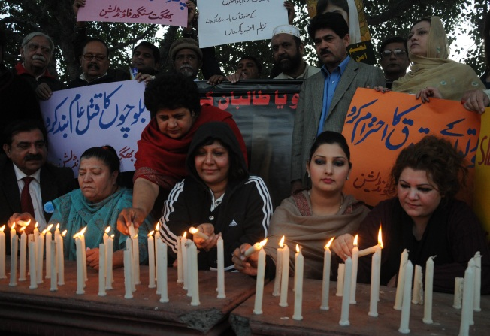
In Pakistan, the situation of human rights condition is worse and it is increasing at a rapid rate. It has formulated a culture of insecurity in the society.Its main reason trace from poverty and unemployment.Today world’s Human rights day is celebrated with an aim to protect common man freedom of religious, economy and social protections. The situation in Karachi is worse an on daily basis innocent’s people are killed ruthlessly. The situation in other provinces of the country is also worse. Whole population of the country along with NGOs demand from the government to end this human violation citizens and protect the citizens from any insecurity and loss on the any basis, it was said by Tanzeem Al Fajar president AkmalOvaisiPirzada.


President of Baghat Singh FoundationSardar Abdul Malik and chairperson of Arman welfare foundation Amnamalik also exchanged their views on Human Rights importance and the role of the civil society in this regard.The participants also demanded the end of terrorism directed mainly towards the Muslim countries must come to end because it is the basis of human rights violation.

