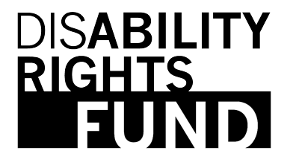

PRESS RELEASE

New Report Expands the Definition of Human Rights

“One in Seven” Documents Progress Made

by Persons with Disabilities

April 1, 2013
FOR IMMEDIATE RELEASE
Contact: Diana Samarasan, Executive Director, Disability Rights Fund
Telephone: 617-261-4593
Email: dsamarasan@disabilityrightsfund.org

Boston, MA – Today, the Disability Rights Fund (DRF) released “One in Seven,” a report that charts the progress made by Disabled Persons’ Organizations around the world in making their voices heard. The report highlights how DRF has supported this growth in its first four years.

“Now, more and more persons with disabilities reject being treated as objects of charity. They are asserting their rights and being heard,” said Diana Samarasan, DRF’s Executive Director. “This report illustrates the growth of our organization and the disability rights movement around the world since 2008, when the Convention on the Rights of Persons with Disabilities (CRPD) entered into force.” Since 2008, DRF has grown grantmaking from seven to 24 countries in six regions of the world and from $800,000 to more than $9 million.

“One in Seven” takes its name from the World Health Organization/World Bank statistic that more than a billion people in the world today have disabilities. This report profiles disability rights activists who are overcoming attitudinal, environmental, institutional and political barriers to participate fully in society. They represent organizations in countries such as Bangladesh, Fiji, Indonesia, Uganda, and Peru.

This report was written and produced in partnership with Free Range Studios and photographer/journalist Andy Isaacson.

For more information, see “One in Seven,” available on DRF’s website http://www.disabilityrightsfund.org/oneinseven

###
About the Disability Rights Fund and the Disability Rights Advocacy Fund
Created in 2008, DRF is a grantmaking collaborative between donors and the global disability community, which empowers disabled persons’ organizations in the Global South to participate in ratification, implementation, and monitoring of the United Nations Convention on the Rights of Persons with Disabilities. DRF’s sister fund, the Disability Rights Advocacy Fund, supports advocacy for legislative change in its target countries. To date, DRF and DRAF have distributed more than $9 million in grants to nearly 200 disabled persons’ organizations in 22 countries.

The Funds’ donors include the American Jewish World Service, Australian Aid, the U.K. Government, the Leir Charitable Foundations, The Foundation to Promote Open Society, part of the Open Society Foundations, and The Sigrid Rausing Trust.

