Report: ‘Moving from margins; Mainstreaming Disabilities in Pakistan’
Karachi 24th November 2014
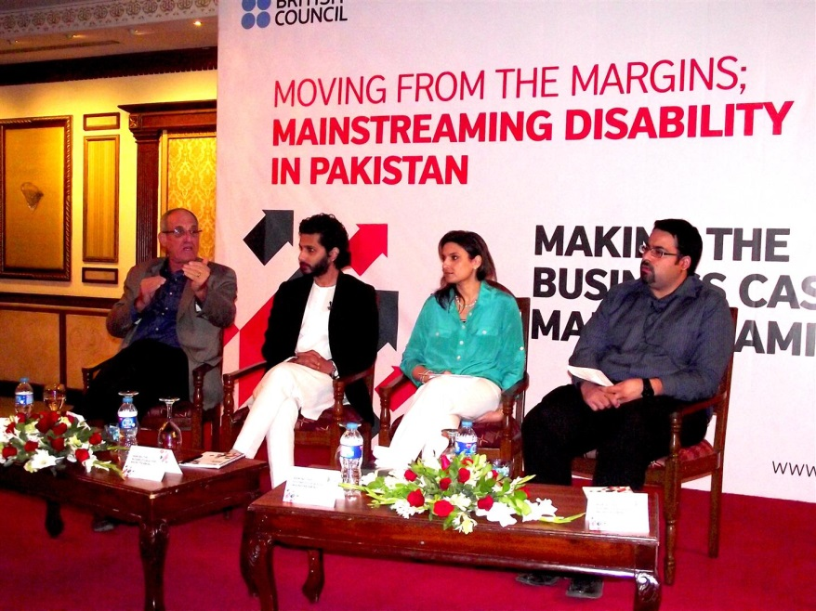
The British Council on Monday organised the second in a series of three policy dialogues focusing on the full inclusion of persons with disabilities in Pakistan. These dialogues are a result of a recently released research report by the British Council titled ‘Moving from margins; Mainstreaming Disabilities in Pakistan’ which states that there are between 3.3 – 27 million persons with disabilities living in Pakistan, depending on numbers via government statistics or through other agencies. The inclusion of persons with disability in Pakistani society, in mainstream education, and their progress in the professional sphere of life is hampered by insufficient resources and poor access to quality education or employment opportunities.
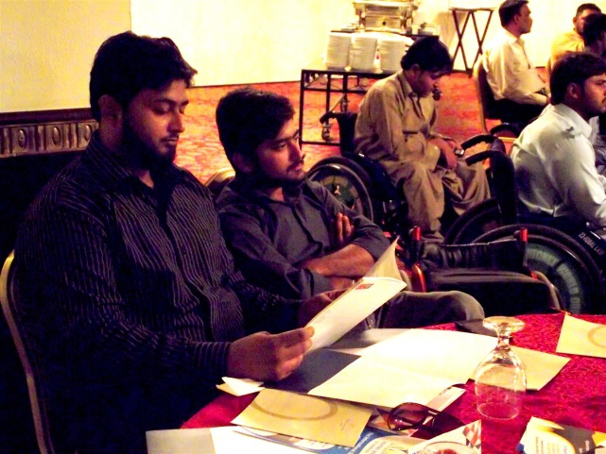
The Karachi policy dialogue titled ‘Making the Business case for Mainstreaming’ focused on the challenges persons with disabilities face in their daily life and how governmental, educational and social institutions can do their part to improve the current scenario in Pakistan.
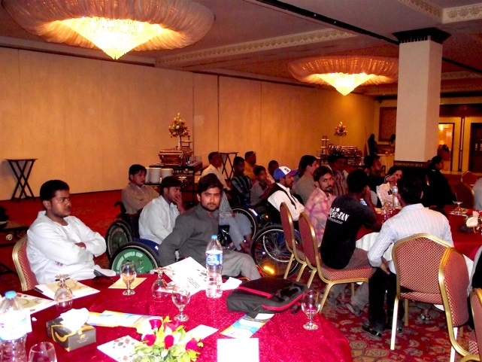
Held at the Pearl Continental, the policy dialogue featured representatives from the government, policy makers, donor agencies, students, teachers, corporate sectors, civil society organisations and persons with disability. They all shared their views in the same forum and discussed what measures need to be taken to move towards a more inclusive environment for people with special needs. Barbara Wickham, British Council Pakistan’s Director Sindh and Balochistan opened the policy dialogue and focused on how important it is to include persons with disabilities in the country’s developmental sector and to provide them with resources that enable them to reach their full potential.
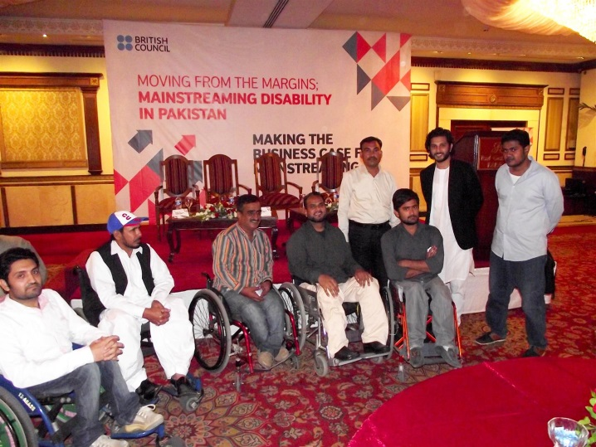
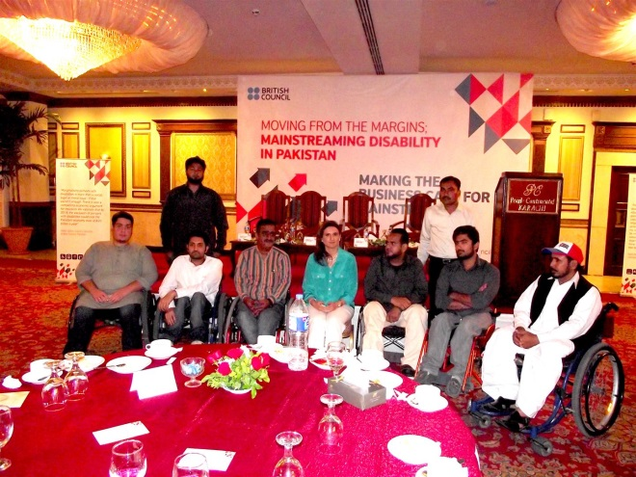
In Pakistan, persons with disabilities can contribute 4.9-6.3% of the total GDP, yet such a productive resource remains untapped due to the lack of awareness and scarcity of proper measures put in place. At the event, the panel discussion, debated ways in which persons with disabilities can be included into the regular employment and educational industry and become contributing members of society. The panel was chaired by Dr. Maryam Rab, Director Research Evaluation and Monitoring (REMU), British Council, and featured Mr. Omair Ahmed, Director NOWPDP, Mr. Ovais, Project Manager and Executive Committee Member, Karachi Vocational Training Centre, Ms. Shafaq Omar, Director HR, Unilever and Mr. Richard Geary, Founder and Director, Family Education Services. The panellists emphasised the significance of these issues and argued strongly for the promotion of the framework of inclusion not just in education, but in all segments of society including employment for persons with disabilities. Many people argued for better links to be made between the corporate sector and civil society organisations, this is the way to initiate change and advocate a single voice.
Nice step taken by British council towards an approach of Inclusive Environment. This start could break the barriers which are responsible for marginalizing the persons with disability Pakistan. Provided; this process of bridging the grass root organizations and their leaders are involved in all basic research and analysis work they are heading to.
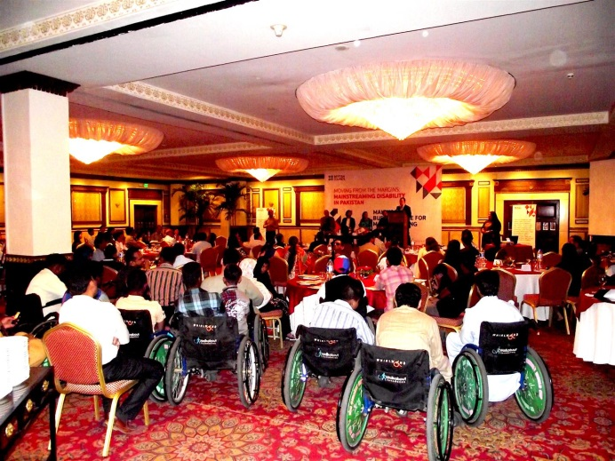
The honorable speakers shared their views upon the current situation of policies and Standards for the rights of PWDs of Pakistan and pointed the sectors which are lacking in this regard. They discussed how important is it strive towards the change. A change which can lead to a turn that can include the 15% of Pakistan's population (PWDs) to contribute for the development of the country.

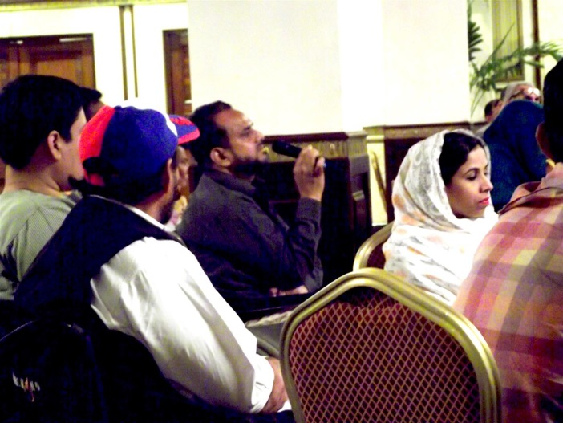
Mobin Uddin taking the opportunity to speak for the rights of PWDs, geared his legit words and also added some of his views on the published report which could be more beneficial and effective for the PWDs of Pakistan.
He discussed the ground realities of the barriers against the PWDs in the country, the main points which he discussed were:
1. The attitude of corporate/public sector towards the DPOs working on Grass root level and how important is their acceptance to make the chain survive in this current situation of the country.
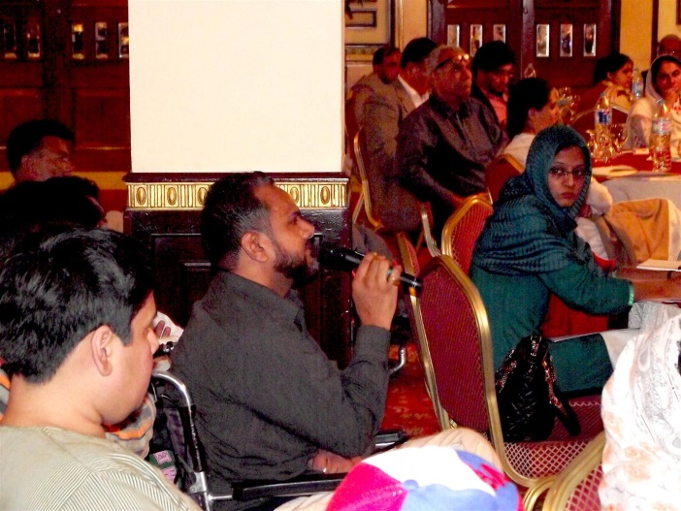
2. Emphasised upon publishing the report in the local languages, so that it could be understood by majority of the PWDs and its contribution is more effective.
3. Highlighted the importance on implementation of UNCRPD by the public and corporate sector.
4. Explained the issue of wrong statistics of PWDs in Pakistan and discussed how important is the survey and census for knowing the exact figures.
5. Questioned them about the policies and Standards for the DPOs working in Pakistan.

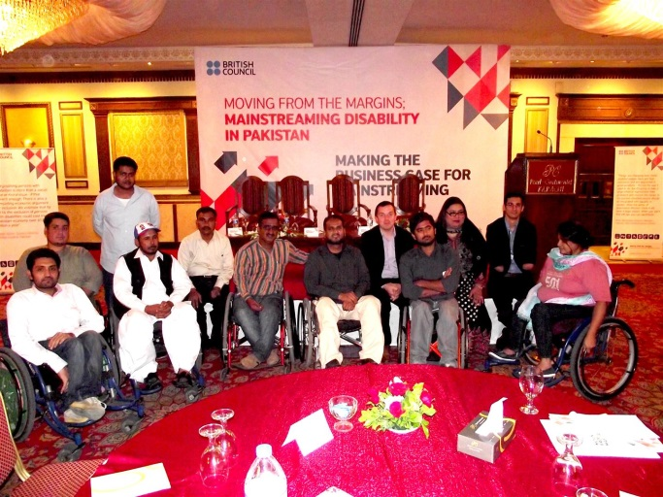
Executives of PDPI and Estanara Group which participated in this event:
M. Mobin Uddin- President of PDPI (Pakistan Disabled People’s International) and CEO Estanara Group,
Jawaid Raees - General Secretary PDPI and member of PDPI associate organizations, M. Afzal Uddin - Director Estanara Group and Bilal Ahmed- Coordinator to President PDPI.

