SPC marks Human Rights Day with national awards in six Pacific countries

10 December 2013
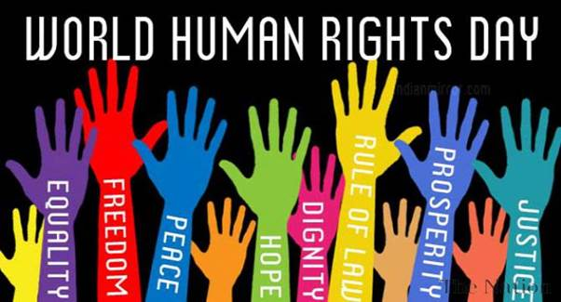

Suva – To mark International Human Rights Day today, 10 December 2014, the Secretariat of the Pacific Community (SPC) is partnering with government ministries in the Federated States of Micronesia, Kiribati, Samoa, Solomon Islands, Tonga and Tuvalu, to present individuals and organisations with Human Rights Awards.

‘The National Human Rights Awards initiative is aimed at rewarding and celebrating outstanding work in human rights in the Pacific region and also to send a clear message to human rights defenders that the Pacific community is grateful for, and supports, their tireless efforts to promote human rights for all,’ the Deputy Director of SPC’s Regional Rights Resource Team (RRRT), Mark Atterton, said.

The theme for the awards is ‘human rights in everyday life’, which covers many aspects of our daily lives, including rights to food, shelter, education, health, protection, freedom of expression and many more.

The Pacific is not immune to human rights violations, with violence against women a critical concern for the region. According to studies by the United Nations Population Fund (UNFPA) in collaboration with SPC, the Pacific region has some of the highest rates of violence against women in the world.
National studies in 2009 and 2010, in Samoa, Kiribati, the Solomon Islands, Tonga, Fiji and Vanuatu, indicate that the rates of intimate partner violence are as high as 60 to 70%. Inadequate laws and policies fail to protect women and their families, and impact adversely on the development of a country.
At a recent SPC-RRRT regional lawyers’ consultation, former high court judge in Fiji, Madam Mere Pulea, encouraged lawyers of the region to ‘be at the forefront to challenge inequalities and discrimination faced by women, and to play a critical role for the benefit of society.’
‘The need to champion gender equality is pivotal to the development and realisation of human rights, and to sustainable development in the region,’ said Mark Atterton.
SPC RRRT won the prestigious UNICEF Maurice Pate Award in 1998 for its pioneering work in promoting human rights education for women and children in the Pacific. Since then, SPC RRRT has been offering the Pacific Human Rights Awards to encourage the development of a human rights culture that will protect the rights and promote the well-being of disadvantaged and vulnerable groups.
The 2014 national awards include:

Kiribati
Rikiaua Takeke
Special recognition for highlighting the right to religion through the documentation of Catechist Tikarerei Takirua’s life story of service to the people of Kiribati.

Selaina Tekonnang
Special recognition for highlighting the right to marriage and to be free from violence through poetry.

Wayne Uan
Special recognition for highlighting the right to participate in any community activities without distinction of any kind such as sex, colour, race, religion or other status.

Samoa
Aoga Fiamalamalama
Special recognition for promoting the right of a child to education in Samoa, including children with disabilities, through role play.

Deborah Jacinta Leu’o
Special recognition for promoting human rights in Samoa through creative drawing.

Faaolo Utumapu-Utailesolo
Special recognition for highlighting the rights of persons with disabilities through the documentation of her personal life story.

Hemiriah Ioane
Special recognition for highlighting the right to education through creative writing.

Nu’ufou Isaia
Special recognition for promoting the right to education for children with disabilities in Samoa, through visual art.

Piu Maneralokina Filipo
Special recognition for highlighting human rights through creative writing.

Samoa Fa’afafine Association
In recognition of the contribution to the promotion of the human rights of marginalised groups, including Fa’afafine and LGBTI groups in Samoa.

Samoa National Youth Council
Special recognition for promoting the right to be heard and of freedom of expression in Samoa through audio visual arts.

Samoa Returnees Charitable Trust
Contribution to advancing the right to freedom from discrimination of Samoan deportees rehabilitating in the community and in community outreach programmes.

Sinalaua Papatoetoe Tupolo
Special recognition for highlighting the right to education, respect and equality through the documentation of her personal life story.

Taiese Taiese
Special recognition for highlighting the right of children to social protection through creative writing.

Tiapapata Art Centre
Special recognition for advancing the right to develop life skills and the right to participate in cultural life, through the Breakthrough initiative, aimed at supporting people affected by trauma and abuse.

Solomon Islands
Br. Gorge Van Der Sant
Special recognition for contribution to advancing the right to education for young persons with disabilities in Solomon Islands.

Community Based Rehabilitation Unit
Special recognition for contribution to advancing the rights of persons with disabilities in Solomon Islands.

Tonga
Women and Children Crisis Centre
Special recognition for advancing the rights of girls in Tonga to be free from domestic violence and sexual abuse.

Talitha Girls
Special recognition for highlighting the rights of single mothers to education and to be respected with equal opportunity.

Elenga Mailangi
Special recognition for highlighting the right to employment and family support in Tonga.

Tuvalu
Fusi Alofa Association
Special Recognition for contribution to advancing the rights of persons with disabilities in Tuvalu.

Talafai Youth Group
Special recognition for contribution to advancing the rights of children to education through support to pre-school building construction on the island of Nanumago, Tuvalu.

SPC RRRT works to build a culture of human rights, and assists nation states to commit to, and observe, international human rights standards. SPC RRRT is a programme under the Social Development Division of the Secretariat of the Pacific Community and is funded by the Australian Government.

For more information, please contact Jilda Shem, SPC RRRT Communications Officer, on +679 330 5994, or email jildas@spc.int

