Report: People of Substance – Aspire to Inspire

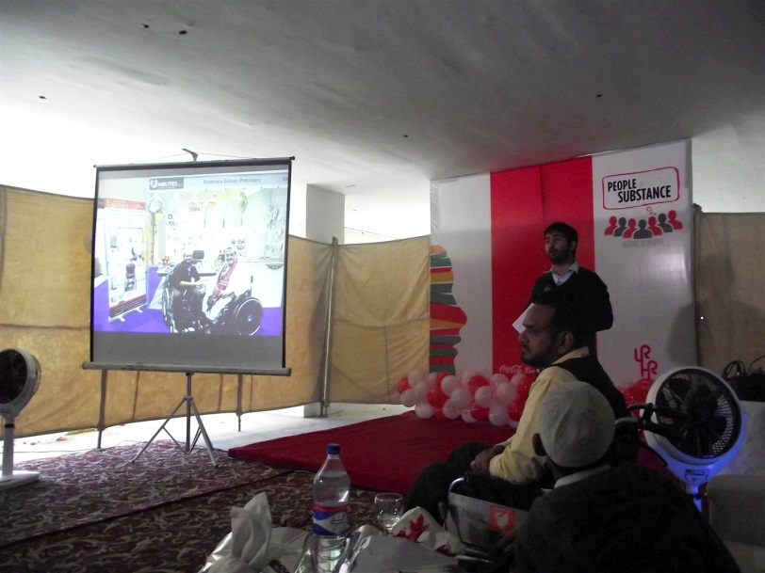
On 27th of Jan 2015 Coca Cola company ltd.’s CSR organized an event “People of Substance - Aspire to inspire” for the motivation of their Employees. They invited successful PWDs (Persons with disabilities) as motivational speakers to share their inspirational journey of life to set an example for enable population.
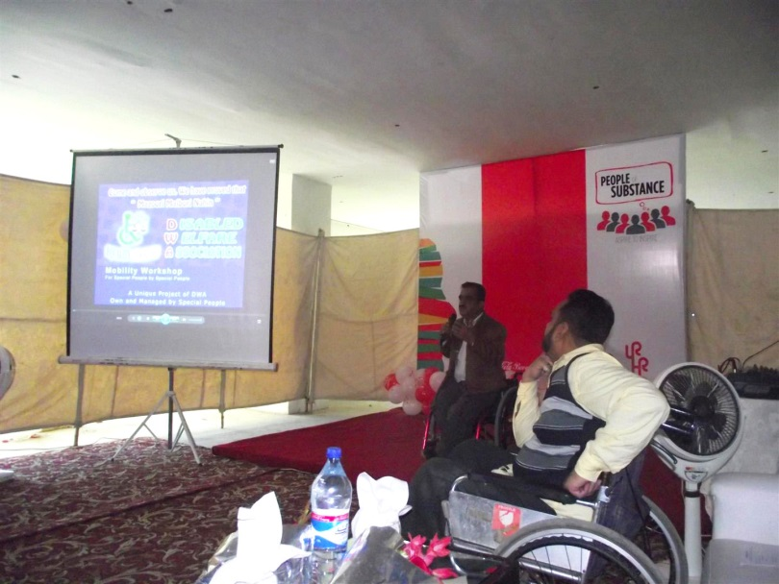
The session started with the introduction of the speakers with presenting their profile to the audience, and then the speakers were invited to present.

Jawaid Rais- President of DWA (Disabled Welfare Association) & General Secretary PDPI (Pakistan Disabled People’s International) gave a presentation on his Disability and barriers he faced in his life until now with it, establishment of DWA and shared some video clips from his works that were covered by Media.

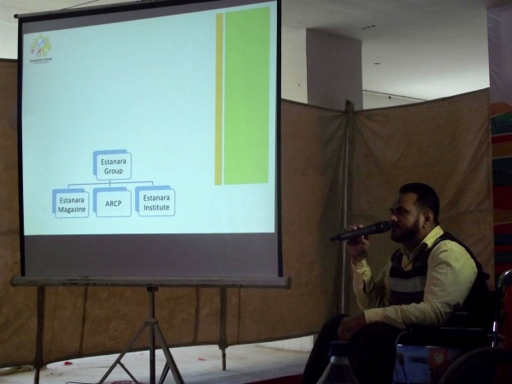
M. Mobin Uddin- CEO of Estanara Group & President of PDPI (Pakistan Disabled People’s International) geared up a motivational speech on his Disability/ Security measures to be taken related to disability issues, he highlighted the difficulties he faced till today in everyday life and how he achieved his goals with the presence of his disability and his endeavor initiated the Estanara Group. He gave a Multimedia Presentation describing his organization and its works for the past 18 years and concluding it with a motivational Video Song.
Some of the NGO’s working for Persons with Disabilities (PWDs) were also invited with their representatives to share words regarding achievers of in the list PWDs.
This initiative taken by Coca Cola ltd is really appreciable and is setting up an example for other listed companies to take such steps for the motivation of their employees and inclusion of PWDs with their acknowledgement and self-actualization.
At the End of the program Alizay Abid presented a bouquet to Jawaid Rais & M. Mobin Uddin as an appreciation of their words and thanking for the participation.
M. Afzal Uddin,
Director,
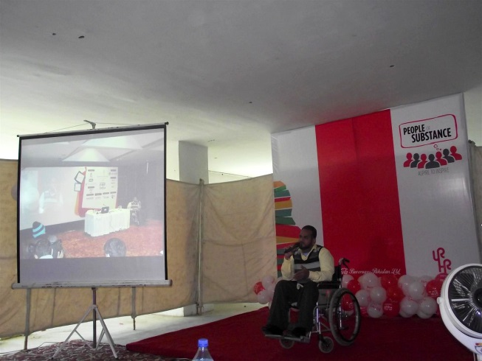
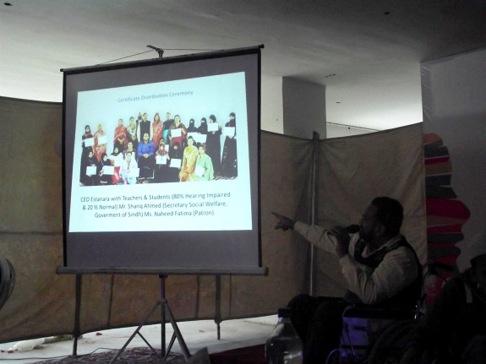
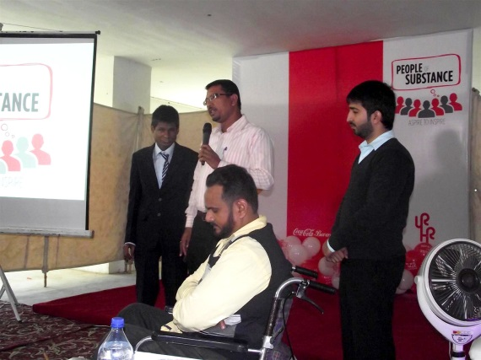
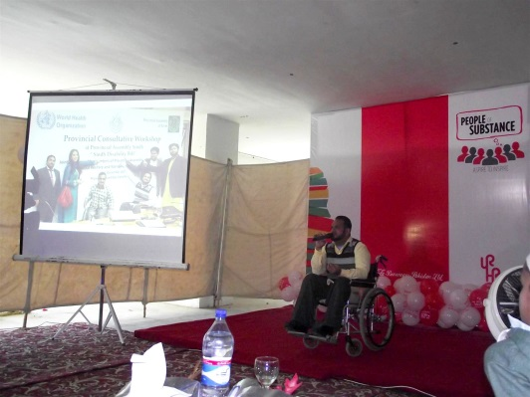
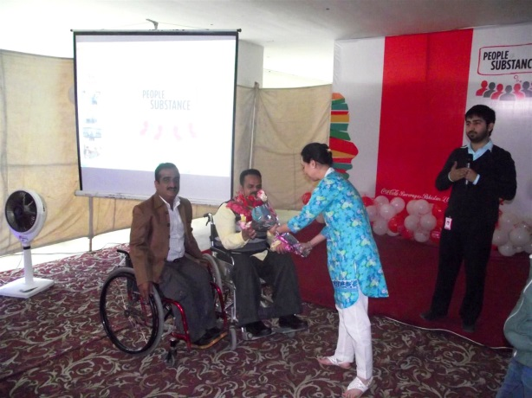
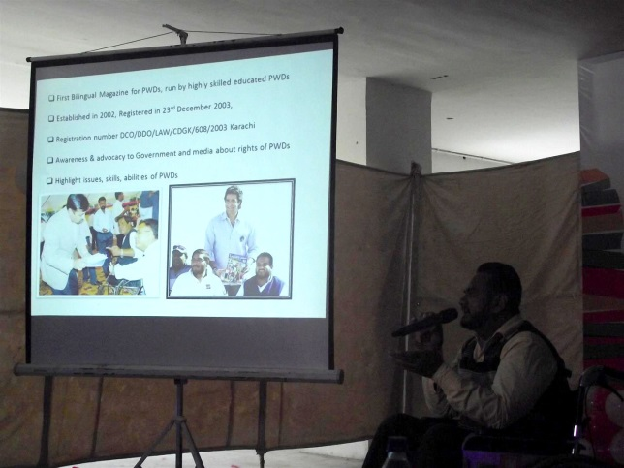
Estanara Group

